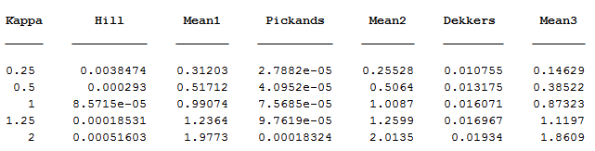

|  |  |  |  |  |
| --- | --- | --- | --- | --- |
| **Kappa\sigma=0.5** | **Kappa (Pickands)** | **Kappa using (GM)** | **Sigma with Kappa (Pickands)** | **Kappa (GM) with sigma(IA)** |
| 0.25 | 0.25528 | 0.2501 | 0.500019 | 0.4998 |
| 0.5 | 0.5064 | 0.5005 | 0.499701 | 0.4996 |
| 1 | 1.0087 | 1.0004 | 0.500015 | 0.4993 |
| 1.25 | 1.2599 | 1.20003 | 0.499675 | 0.499975 |
| 2 | 2.0135 | 1.9774 | 0.500089 | 0.5073 |

Please organize the tables as follows

|  |  |  |  |  |  |  |  |  |  |
| --- | --- | --- | --- | --- | --- | --- | --- | --- | --- |
| **Generator Parameters** | | **IA Estimates** | | | | **Pickands Estimates** | | | |
| **Scale** | **Shape** | **Scale** | | **Shape** | | **Scale** | | **Shape** | |
| **-** | **-** | **Mean** | **MSE** | **Mean** | **MSE** | **Mean** | **MSE** | **Mean** | **MSE** |
| 0.5 |  |  |  |  |  |  |  |  |  |
| 0.5 |  |  |  |  |  |  |  |  |  |
| 0.5 |  |  |  |  |  |  |  |  |  |
| 0.5 |  |  |  |  |  |  |  |  |  |
| 0.5 |  |  |  |  |  |  |  |  |  |